

# Panipat Institute of Engineering & Technology, Samalkha (Haryana)

**Computer Science & Engineering Department**

# Internet Technology and Management Lab PC-CS210AL

**Submitted to: Submitted by:**

# Mr. Navneet Verma Anmol Baranwal

(CSE Department) 2820208

CSE 4th Sem.

# Affiliated to

**Kurukshetra University Kurukshetra, India**

|  |  |  |  |
| --- | --- | --- | --- |
| **S.**  **No.** | **PRACTICAL** | **DATE** | **SIGNATURE** |
|  | **PC SOFTWARE:** |  |  |
| **1.** | To prepare the Your Bio Data using MS Word. |  |  |
| **2.** | To prepare the list of marks obtained by students in different subjects and show with the help of chart/graph the average, min and max marks in each subject. |  |  |
| **3.** | Prepare a presentation explaining the  facilities/infrastructure available in your college/institute. |  |  |
| **4.** | Design Web pages containing information of the deptt. |  |  |
|  | **HTML LISTS:** |  |  |
| **5.** | Create a new document that takes the format  of a business letter. Combine <P> and  <BR> tags to properly separate the different parts of the documents. Such as the address, greeting, content and  signature. What works best for each? |  |  |
| **6.** | Create a document that uses multiple <BR> and <P> tags, and put returns between  <PRE> tags to add blank lines to your document see if your browser senders  them differently. |  |  |
| **7.** | Create a document using the <PRE>tags to work as an invoice or bill of sale, complete with aligned dollar values and a total.  Remember not to use the Tab key, and avoid  using emphasis tags like <B> or <EM> within your list. |  |  |
| **8.** | Create a seven-item ordered list using Roman numerals. After the fifth item, increase the next list value by 5. |  |  |
| **9.** | Beginning with an ordered list, create a list that nests both an unordered list and a definition list. |  |  |
| **10.** | Use the ALIGN attribute of an <IMG> tags to align another image to the top of the first image.. play with this feature, aligning images  to TOP, MIDDLE and BOTTOM. |  |  |

|  |  |  |  |
| --- | --- | --- | --- |
| **11.** | Create a ‘table of contents’ style page (using regular and section links) and loads a different document for each chapter or section of the  document. |  |  |

**Practical No. 1 Statement:** To prepare the Your Bio Data using MS Word.

**Software and hardware requirements:** Software-MS Office, Hardware-2GB RAM and 12GB disk space,pentinum processor

# Practical:

**RESUME**

Anmol Baranwal

Bhadohi(221401)

Uttar Pradesh

8931073435

[anmolbaranwal119@gmail.com](mailto:anmolbaranwal119@gmail.com)

**CARRIER'S OBJECTIVE:** Aspiring to become an entrepreneur and financially independent. I have a solid understanding of UI and UX principles thanks to Google-led courses, and I've created multiple designs that adhere to those concepts.

I'm also a passionate Web Developer who believes in learning by implementing the skills. Solid foundational knowledge of Frontend and building efficient websites with a visual appeal using a combination of frameworks, tools, and my skill-sets.

# QUALIFICATIONS

|  |  |  |  |  |
| --- | --- | --- | --- | --- |
| **Qualification** | **Board/ University** | **College/ School** | **Year** | **%age** |
| **Matric** | **CBSE** | **Wood Ward Public**  **School** | **2017** | **95%** |
| **Senior Secondary** | **CBSE** | **Green View Public**  **School** | **2019** | **88.2%** |
| **B. Tech.(CSE)** | **KUK** | **Panipat Institute of Engineering and Technology** | **2020-**  **24** |  |

**QUALITIES**

* Active participant in different hackathons, business plan, ideation contests, and part of global developer community
* Responsible student with a excellent academic record looking to make advance projects with the experience and knowledge

# STRENGTH

* Keen eye towards User Interface
* Good understanding of front end technology
* Communicating : Communication Skills
* To take account of every detail before doing a project
* Honesty and Integrity
* Collaborative Skills

# WEAKNESS

* Habit of exploring so many things which may ultimately waste my time in a long term.

**DECLARATION:**

I hereby declare that the above information is correct to the best of my knowledge and behalf.

# 

# Anmol Baranwal

# Practical No.-2

**Statement:** To prepare the list of marks obtained by students in different subjects and show with the help of chart/graph the average, min and max marks in each subject.

# Software and hardware requirements:

Software-MS Office

Hardware-2GB RAM and 12GB disk space, Pentium processor

# Practical:

|  |  |  |  |  |  |  |  |
| --- | --- | --- | --- | --- | --- | --- | --- |
| S.NO. | NAME | PHYSICS | MATHS-1 | EDG | PPS | BIOLOGY | TOTAL |
| 1 | Rohit | 97 | 100 | 90 | 89 | 85 | 461 |
| 2 | Ankit | 95 | 80 | 78 | 90 | 70 | 416 |
| 3 | Agni | 90 | 80 | 70 | 60 | 50 | 350 |
| 4 | Rahul | 90 | 76 | 80 | 68 | 56 | 370 |
| 5 | Mohit | 89 | 65 | 78 | 86 | 63 | 381 |
|  | Minimum | 89 | 65 | 70 | 60 | 50 |  |
|  | Maximum | 97 | 100 | 90 | 90 | 85 |  |
|  | Average | 92.2 | 80.2 | 79.2 | 78.6 | 64.8 |  |

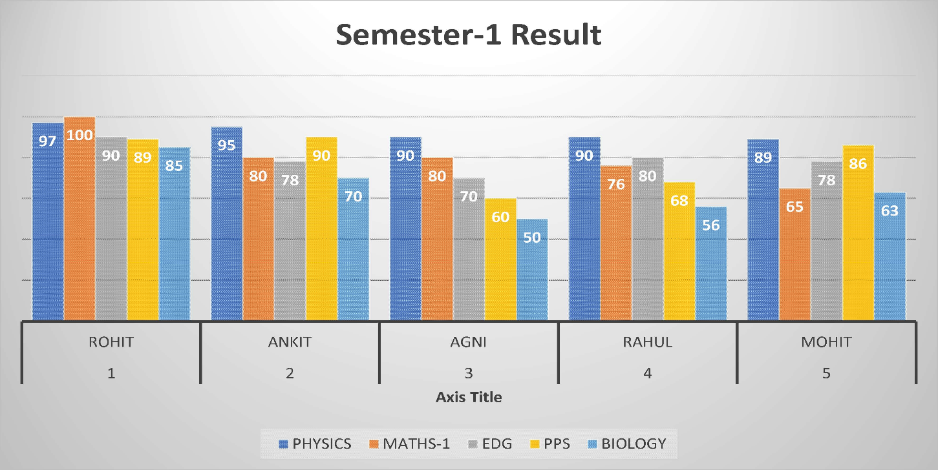

# Practical-3

**Problem Statement:** Prepare a presentation explaining the facilities/infrastruct

-ure available in your college/institute.

# Software and hardware requirements:

Software-MS Office

Hardware-2GB RAM and 12GB disk space, Pentium processor

# Practical:

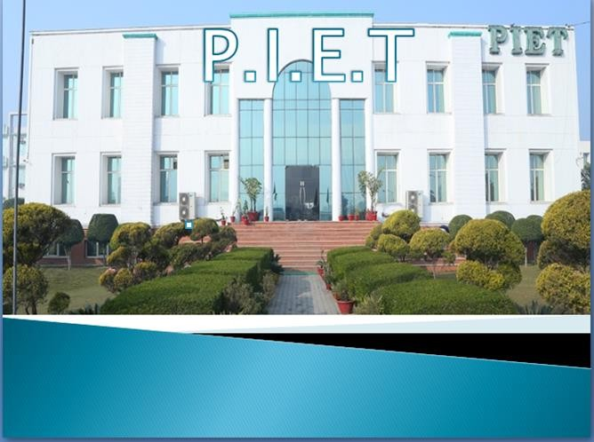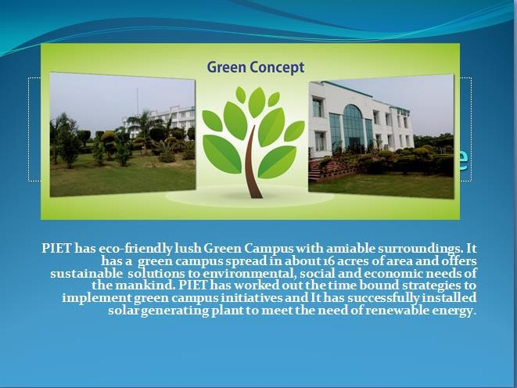



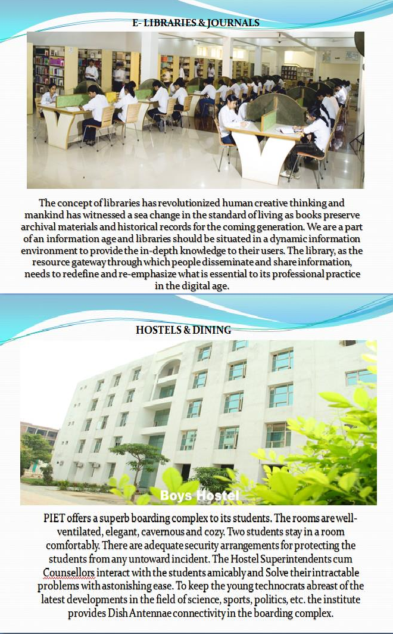

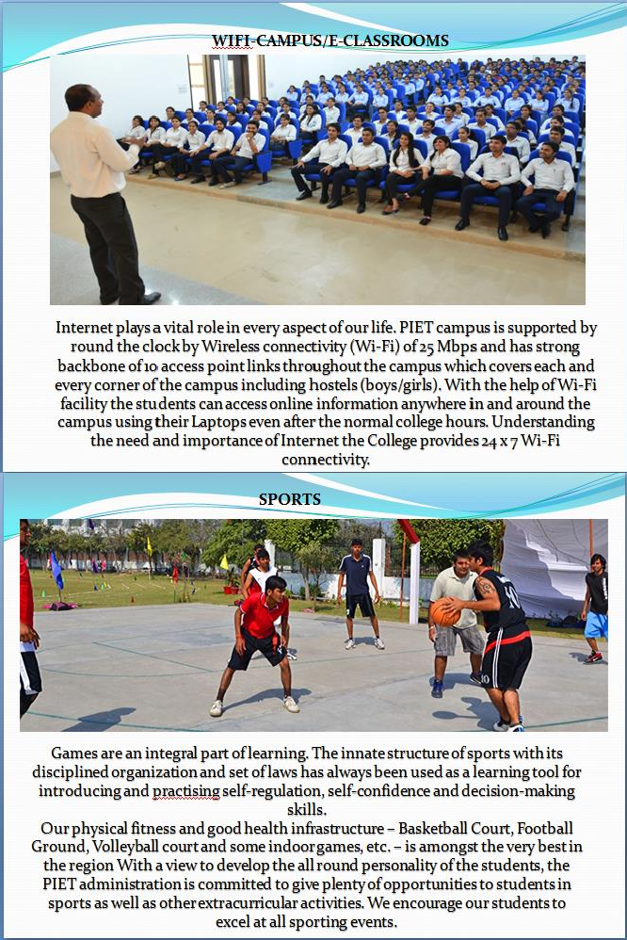

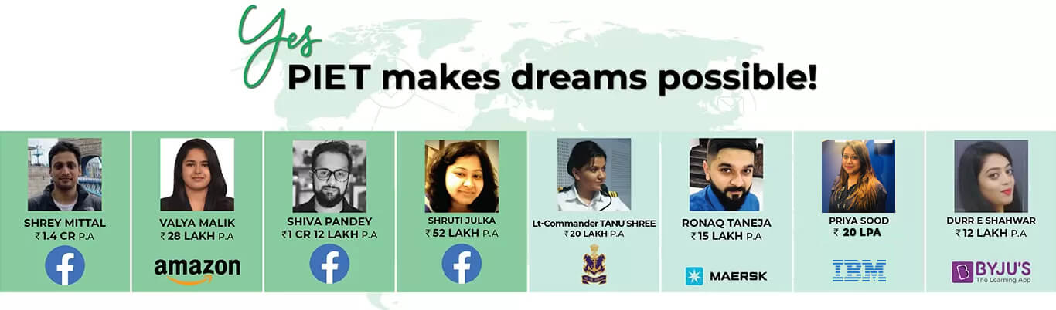

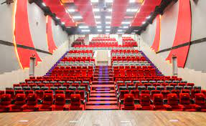

# Practical-4

**Problem Statement:** Design Web pages containing information of the department.

# Software and hardware requirements:

Software: Notepad, Internet Explorer

Hardware-2GB RAM and 12GB disk space, Pentium processor

# Practical: Coding:

# HTML LISTS:

**Practical-5**

**Statement:** Create a new document that takes the format of a business letter. Combine <P> and <BR> tags to properly separate the different parts of the documents. Such as the address, greeting, content and signature. What works best for each?

# Software and hardware requirements:

Software: Notepad, Internet Explorer

Hardware-2GB RAM and 12GB disk space, Pentium processor

# Practical: Coding:

# 

**Output:**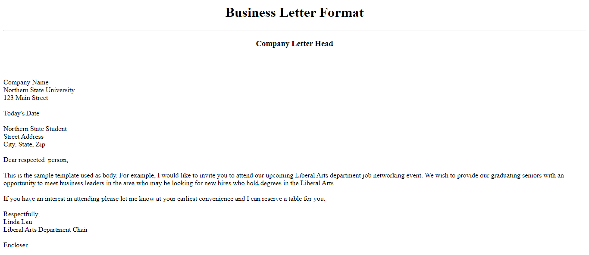

# Practical-6

**Statement:** Create a document that uses multiple <BR> and <P> tags, and put returns between <PRE> tags to add blank lines to your document see if your browser senders them differently.

# Software and hardware requirements:

Software: Notepad, internet Explorer

Hardware-2GB RAM and 12GB disk space, Pentium processor

# Practical: Coding:

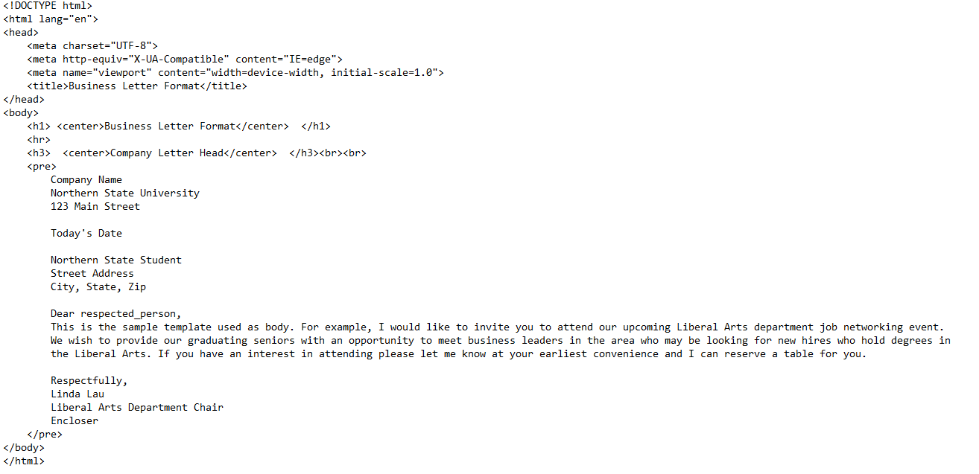

**Output:**

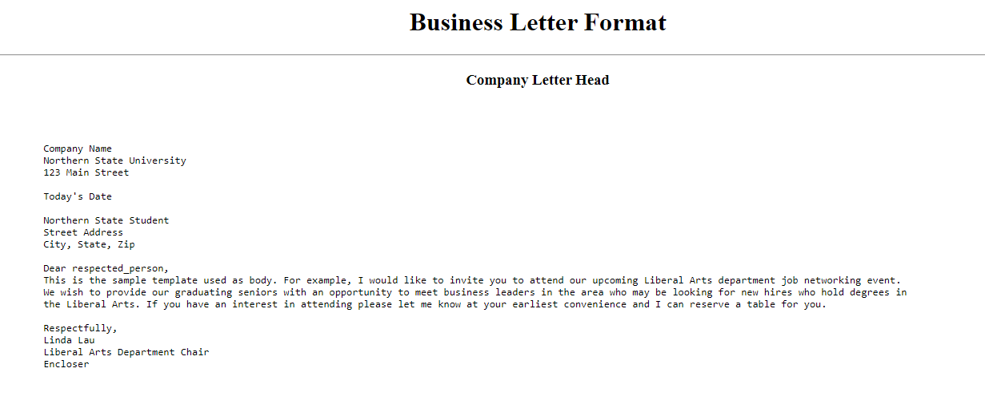

# Practical-7

**Statement:** Create a document using the <PRE>tags to work as an invoice or bill of sale, complete with aligned dollar values and a total. Remember not to use the Tab key, and avoid using emphasis tags like <B> or <EM> within your list.

**Software and hardware requirements:** Software: Notepad, internet Explorer Hardware-2GB RAM and 12GB disk space, Pentium processor

# Practical: Coding:

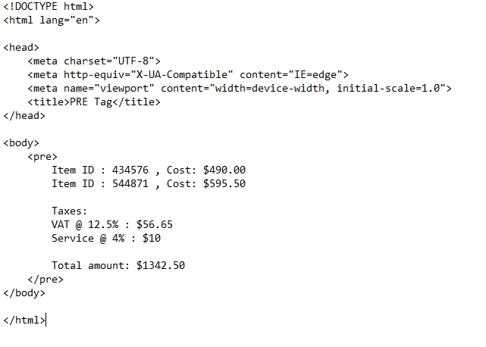

**Output:**

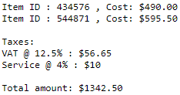

# Practical-8

**Problem Statement:** Create a seven-item ordered list using Roman numerals. After the fifth item, increase the next list value by 5.

# Software and hardware requirements:

Software: Notepad, internet Explorer

Hardware-2GB RAM and 12GB disk space, Pentium processor

**Practical:**

# Coding:

# 

** Output:**

# Practical-9

**Problem Statement:** Beginning with an ordered list, create a list that nests both an unordered list and a definition list.

# Software and hardware requirements:

Software: Notepad, internet Explorer

Hardware-2GB RAM and 12GB disk space, Pentium processor

# Practical: Coding:

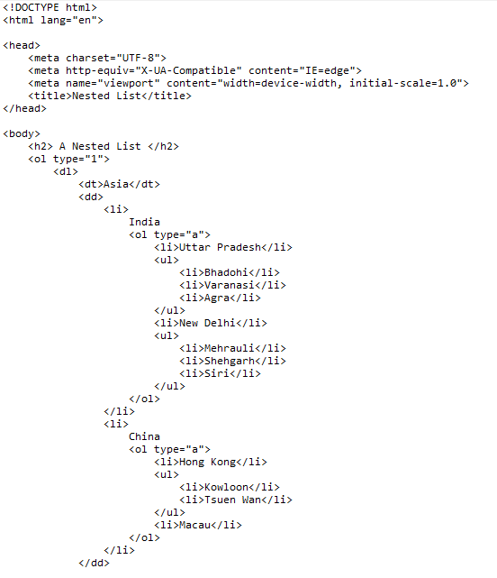

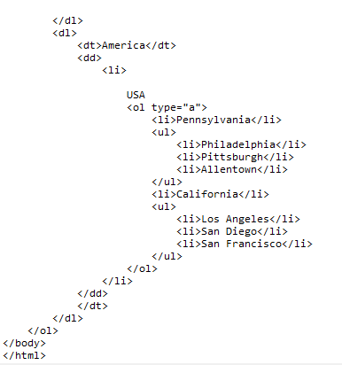

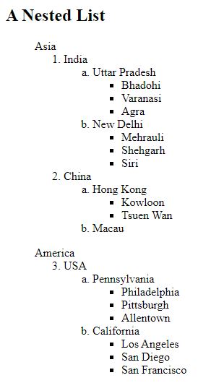**Output:**

# Practical-10

**Problem Statement:** Use the ALIGN attribute of an tags to align another image to the top of the first image play with this feature, aligning images to TOP, MIDDLE and BOTTOM.

**Software and hardware requirements:** Software: Notepad, internet Explorer Hardware-2GB RAM and 12GB disk space, Pentium processor

# Practical: Coding:

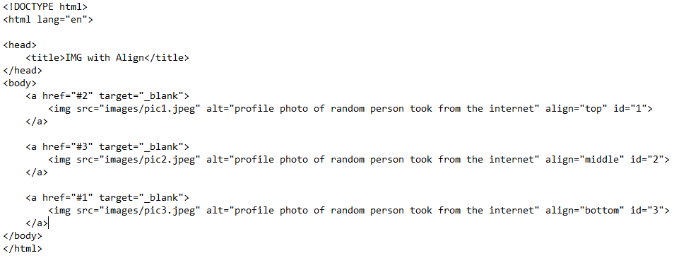

**OUTPUT:**



# Practical-11

**Statement:** Create a ‘table of contents’ style page (using regular and section links) and loads a different document for each chapter or section of the document.

**Software and hardware requirements:** Software: Notepad, internet Explorer Hardware-2GB RAM and 12GB disk space, Pentium processor

# Practical: Coding:

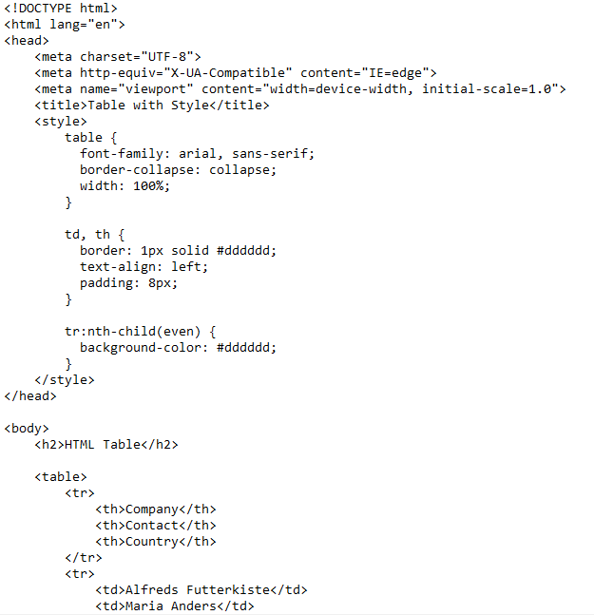

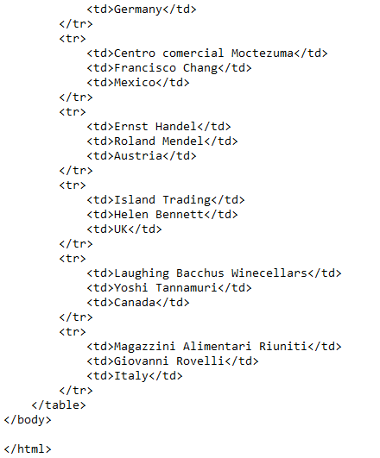

**Output:**

